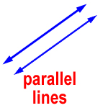Parallel lines: Two lines that don’t intersect or touch each other at any point.
The symbol for parallel lines is ll.
Real life example: The stripes on the US flag a parallel.
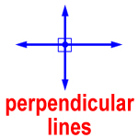Perpendicular lines: Two lines that intersect forming a right angle. The symbol for perpendicular lines is.
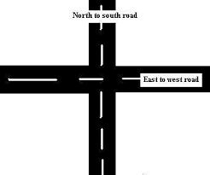Real life example: Some roads intersect creating perpendicular lines.
Postulates:
- Parallel postulate: If there is a line and a point not on the line, then there is exactly one line through the point parallel to the given line.

- Perpendicular postulate: If there is a line and a point not on the line, then there is exactly one line through the point perpendicular to the given line.

